**SQL Questions**

**1. Display Full_MFG_Name in Table B without the MFG Code ( Example: ‘Amphenol’)**

SELECT RIGHT(Full_MFG_Name, LEN(Full_MFG_Name) - CHARINDEX('| ',Full_MFG_Name))

from manufacturer

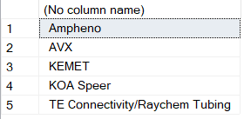

**2. Calculate Total Revenue from Table B**

SELECT Quantity, Unit_Price, Quantity * Unit_Price AS "total revenue"

FROM sales

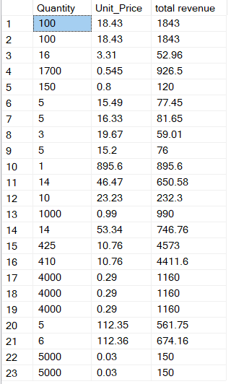

**3. Display the top 10 Products from Table B which made highest profit**

profit = total revenue – total cost profit = Quantity(Unit_price – Unit_Cost)

SELECT TOP (10) Product, Quantity * (Unit_Price - Unit_Cost) AS "total profit"

FROM sales

ORDER BY [total profit] DESC

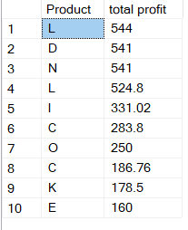

**4. Display total cost, total Price and Margins grouped by Parent_MFG in table A**

margin = (unit price – unit cost)/unit price

Total cost = unit_cost * Quantity

Total price = unit_price * quantity

SELECT manufacturer.Parent_MFG ,

SUM(sales.Quantity * sales.Unit_Cost) AS "total cost",

SUM(sales.Quantity * (sales.Unit_Price - sales.Unit_Cost)) AS "total profit",

SUM((sales.Unit_Price - sales.Unit_Cost)/sales.Unit_Price) AS "margin"

FROM sales

INNER JOIN manufacturer ON sales.MFG_Code = manufacturer.MFG_Code

GROUP BY manufacturer.Parent_MFG

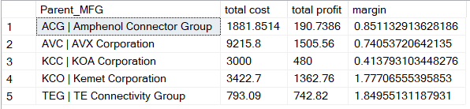

**5. Display the highest selling product and the second highest selling product**

SELECT TOP (2) Product, SUM(Unit_Price * Quantity) AS "total sales"

FROM sales

GROUP BY Product

ORDER BY [total sales] DESC

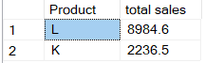

**6. Display the Total Cost and Total Revenue based on Type from Table C and order it in a**

**descending order**

SELECT products.TYPE ,

SUM(sales.Quantity * sales.Unit_Price) AS "total revenue",

SUM(sales.Quantity * sales.Unit_Cost) AS "total cost"

FROM sales

INNER JOIN products ON sales.Product = products.Product

GROUP BY products.TYPE

ORDER BY [total revenue] DESC

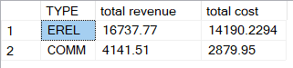

**7. Find which Quarter sold highest number of products**

First quarter of 2017

SELECT SUM(Quantity) AS "number of sold products",

CASE WHEN Date >= '2016-01-01' AND Date <='2016-03-31' THEN 'first Quarter of 2016'

WHEN Date >= '2016-04-01' AND Date <= '2016-06-30' THEN 'second Quarter of 2016'

WHEN Date >= '2016-07-01' AND Date <= '2016-09-30' THEN 'third Quarter of 2016'

WHEN Date >= '2016-10-01' AND Date <= '2016-12-31' THEN 'forth Quarter of 2016'

WHEN Date >= '2017-01-01' AND Date <= '2017-03-31' THEN 'first Quarter of 2017'

WHEN Date >= '2017-04-01' AND Date <= '2017-06-30' THEN 'second Quarter of 2017'

WHEN Date >= '2017-07-01' AND Date <= '2017-09-30' THEN 'third Quarter of 2017'

WHEN Date >= '2017-10-01' AND Date <= '2017-12-31' THEN 'forth Quarter of 2017'

END AS bucket

FROM sales

GROUP BY

CASE WHEN Date >= '2016-01-01' AND Date <='2016-03-31' THEN 'first Quarter of 2016'

WHEN Date >= '2016-04-01' AND Date <= '2016-06-30' THEN 'second Quarter of 2016'

WHEN Date >= '2016-07-01' AND Date <= '2016-09-30' THEN 'third Quarter of 2016'

WHEN Date >= '2016-10-01' AND Date <= '2016-12-31' THEN 'forth Quarter of 2016'

WHEN Date >= '2017-01-01' AND Date <= '2017-03-31' THEN 'first Quarter of 2017'

WHEN Date >= '2017-04-01' AND Date <= '2017-06-30' THEN 'second Quarter of 2017'

WHEN Date >= '2017-07-01' AND Date <= '2017-09-30' THEN 'third Quarter of 2017'

WHEN Date >= '2017-10-01' AND Date <= '2017-12-31' THEN 'forth Quarter of 2017'

end

ORDER BY SUM(Quantity) DESC

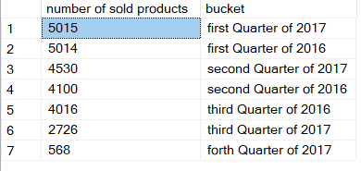

**8. Find which quarter made the highest sale in ‘AUTOMOTIVE’ category In the last year**

We didn’t have any sale in automotive category in the last year (2016), the only sales in Automotive category belongs to 2017.

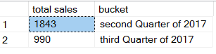

**9. Find the Products in table C that haven’t sold anything ever**

Product P

SELECT products.Product

FROM products

LEFT JOIN sales ON products.Product = sales.Product

WHERE sales.Product IS NULL

